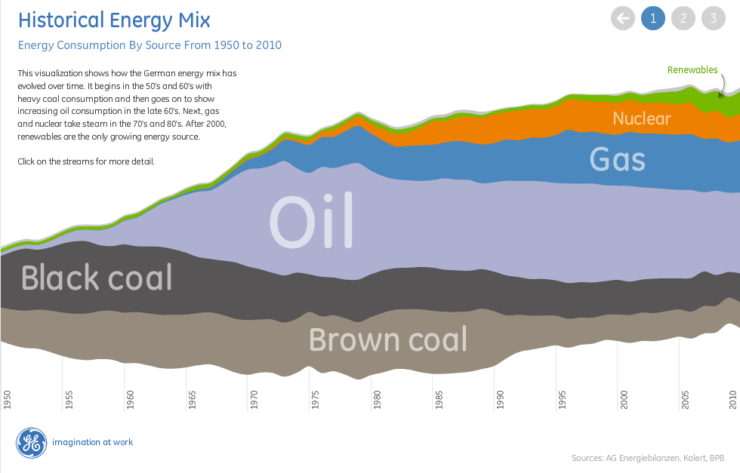

The data visualization above is interesting and predictive for the following reasons:

Clarity: The time series is easily understood by the color and density of each natural resource.

Timing: This graph covers 60 years of data, but one can see seamless transition overtime.

Trending: While one cannot necessarily predict the energy mix from this graphic, one can predict the overall trend and still see spikes and recessions.

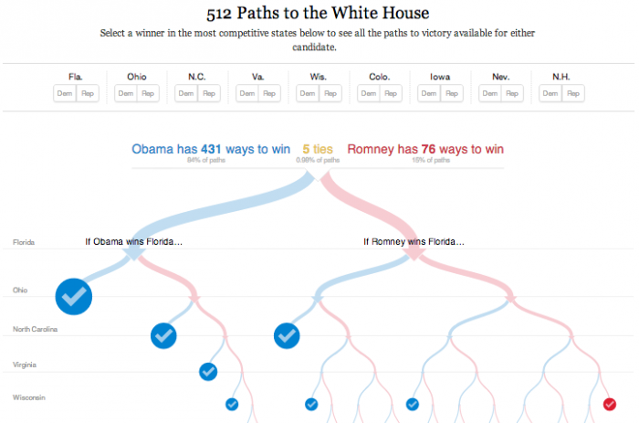

This tree-path graphic is a great predictive visual for the convoluted nature of an election. This graphic highlights the importance of binary outcomes at different state levels. Predicting an election is difficult, but one can see from the graphic above that Romney was not the favorite.